S



# Baldivis Secondary College

### Semester One Examination, 2017

### Question/Answer booklet

# MATHEMATICS

If required by your examination administrator, please place your student identification label in this box

**SPECIALIST**

**UNIT 1**

## Section One:

## Calculator-free

|  |  |  |  |  |  |  |  |  |  |  |
| --- | --- | --- | --- | --- | --- | --- | --- | --- | --- | --- |
| Student Number: In figures |  |  |  |  |  |  |  |  |  |  |

In words

Your name

## Time allowed for this section

Reading time before commencing work: five minutes

Working time: fifty minutes

## Materials required/recommended for this section

***To be provided by the supervisor***

This Question/Answer booklet

Formula sheet

***To be provided by the candidate***

Standard items: pens (blue/black preferred), pencils (including coloured), sharpener, correction fluid/tape, eraser, ruler, highlighters

Special items: nil

## Important note to candidates

No other items may be taken into the examination room. It is **your** responsibility to ensure that you do not have any unauthorised material. If you have any unauthorised material with you, hand it to the supervisor **before** reading any further.

## Structure of this paper

|  |  |  |  |  |  |
| --- | --- | --- | --- | --- | --- |
| Section | Number of questions available | Number of questions to be answered | Working  time (minutes) | Marks available | Percentage of examination |
| Section One:  Calculator-free | 6 | 6 | 50 | 52 | 35 |
| Section Two:  Calculator-assumed | 12 | 12 | 100 | 96 | 65 |
|  | | |  | **Total** | 100 |

|  |  |  |
| --- | --- | --- |
| Markers use only | | |
| Question | Maximum | Mark |
| 1 | 7 |  |
| 2 | 11 |  |
| 3 | 8 |  |
| 4 | 7 |  |
| 5 | 10 |  |
| 6 | 9 |  |
| S1 Total | 52 |  |
| S1 Wt (×0.6731) | 35% |  |
| S2 Wt | 65% |  |
| Total | 100% |  |

## Instructions to candidates

1. The rules for the conduct of examinations are detailed in the school handbook. Sitting this examination implies that you agree to abide by these rules.

2. Write your answers in this Question/Answer booklet.

3. You must be careful to confine your response to the specific question asked and to follow any instructions that are specified to a particular question.

4. Additional working space pages at the end of this Question/Answer booklet are for planning or continuing an answer. If you use these pages, indicate at the original answer, the page number it is planned/continued on and write the question number being planned/continued on the additional working space page.

5. Show all your working clearly. Your working should be in sufficient detail to allow your answers to be checked readily and for marks to be awarded for reasoning. Incorrect answers given without supporting reasoning cannot be allocated any marks. For any question or part question worth more than two marks, valid working or justification is required to receive full marks. If you repeat any question, ensure that you cancel the answer you do not wish to have marked.

6. It is recommended that you do not use pencil, except in diagrams.

7. The Formula sheet is not to be handed in with your Question/Answer booklet.

Section One: Calculator-free 35% (52 Marks)

This section has**six (****6)** questions. Answer **all** questions. Write your answers in the spaces provided.

Working time: 50 minutes.

Question 1 (7 marks)

It can be shown that for all $n≥0,$

$$^{n+1}P_{r}=\frac{n+1}{n-r+1}×{ ^{n}P}_{r}$$

(a) Show that the identity is true when $n=4$ and $r=2$. (2 marks)

Given that $^{8}P_{4}=1 680$, $^{12}P_{5}=95 040$ and $^{12}P_{6}=665 280$, evaluate

(b) $^{11}P_{6}$. (2 marks)

(c) $^{10}P_{4}$. (3 marks)

Question 2 (11 marks)

Three vectors are given by $a=3i-5j$, $b=-2i+7j$ and $c=6i+j$.

(a) Determine

(i) $a+b+c$. (1 mark)

(ii) $|c|$. (1 mark)

(iii) $2a+3b$. (2 marks)

(b) Determine the unit vector $\hat{d}$ that is parallel and in the same direction as $b-a$. (3 marks)

(c) Express $c$ in terms of $a$ and $b$. (4 marks)

Question 3 (8 marks)

(a) Write the inverse of the following true statement and comment on the truth of the inverse statement. (2 marks)

"If the discriminant of the quadratic formula is zero, then the quadratic has just one real root."

(b) Write the converse of the following true statement and comment on the truth of the converse statement. (2 marks)

"If $x>3$ then $x>2$."

(c) Determine the truth of the following statements, using an example or counter-example to support each answer.

(i) If $z∈R$ and $z^{3}$ is an even number then $z$ is an even number. (2 marks)

(ii) If $x,y∈Z$ and $x>y$ then $x^{2}>y^{2}$. (2 marks)

Question 4 (7 marks)

(a) A body moves from $P(2, -3)$ to $Q(-2, 1)$.

(i) Determine the displacement vector $\vec{PQ}$ in component form. (1 mark)

(ii) Determine the magnitude of the vector $\vec{PQ}$. (1 mark)

(b) A force of $6i-6\sqrt{3}j$ N acts on a body. Determine the magnitude of the force and the angle its direction makes with the positive $x$-axis. (2 marks)

(c) A body moves with a velocity of 20 ms-1 at an angle of 135° with the positive $x$-axis. Express the velocity of the body in the form $ai+bj$, where $a$ and $b$ are constants.

(3 marks)

Question 5 (10 marks)

(a) In the diagram below, not drawn to scale, $PQRS$ is a cyclic quadrilateral such that $PS=QS$, $∠RPQ=34°$ and $∠PQR$ is a right-angle.

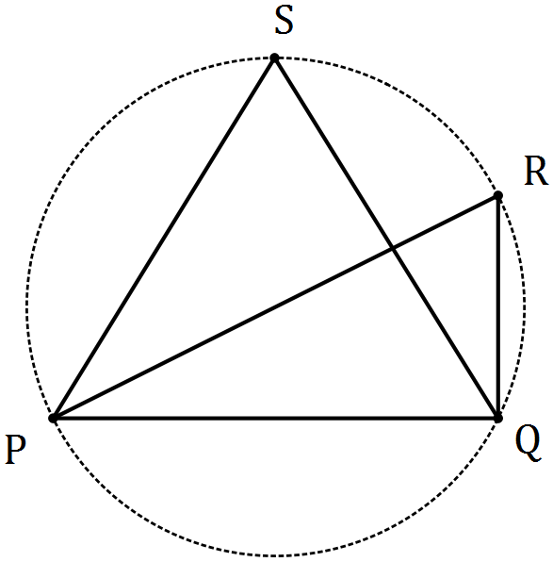

Determine the sizes of

(i) $∠PSQ$. (2 marks)

(ii) $∠RPS$. (2 marks)

(b) In the circle with centre $O$ drawn below, chord $AC$ intersects chord $BD$ at $E$. Explain, with reasoning, why triangles $AED$ and $BEC$ are similar. (3 marks)

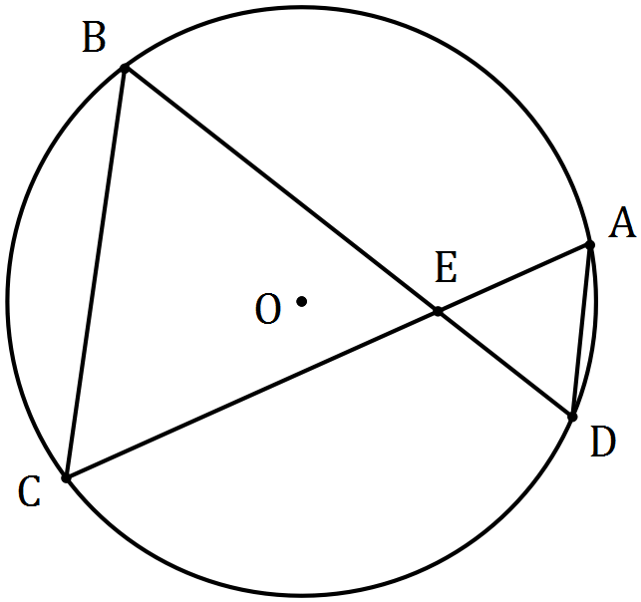

(c) Prove that when two chords of a circle intersect, the product of the lengths of the intervals on one chord equals the product of the lengths of the intervals on the other chord.

(3 marks)

Question 6 (9 marks)

(a) Determine the number of different four-letter passwords that can be made by arranging a selection of four letters chosen from the list P, Q, R, R, R, R and S. (4 marks)

(b) Determine the number of positive integers between 1 and 240 inclusive that are **not** divisible by at least one of the integers 4, 5 or 6. (5 marks)

Additional working space

Question number: _________

© 2017 WA Exam Papers. Baldivis Secondary College has a non-exclusive licence to copy and communicate this paper for non-commercial, educational use within the school. No other copying, communication or use is permitted without the express written permission of WA Exam Papers. SN261-091-1.